T1 and DTI Analyses: Grey Matter

1. Install Freesurfer Version 6

* Installation steps can be found here: <https://surfer.nmr.mgh.harvard.edu/fswiki/ReleaseNotes>
* Software has been tested on: Linux Ubuntu 18.04, Freesurfer Version 6, FSL
* further information
  + <https://surfer.nmr.mgh.harvard.edu/fswiki/LongitudinalProcessing>
  + <https://surfer.nmr.mgh.harvard.edu/fswiki/Tracula>
* Scripts can be run using: ./[script_name] [subject_file]

1. Start Freesurfer´s corssectional pipeline (recon-all)

* Prepare Scripts/ Directory Structure
  + Copy folder SEGMENTATION from 00_Scripts_Freesurfer/SEGMENTATION to own Freesurfer folder
  + go to owndirectory/SEGMENTATION
  + Copy .nii to Input folder
  + Adapt paths definitions for indir, outdir
  + Adapt file names in cp command
  + Run script: 00-copy-renameT1_X to copy T1.nii from data files in Input directory and rename files as SubjectID_T1.nii for pre and post
  + Input: .nii file from subject directory
  + Output: renamed T1.nii file in Input directory
  + Scripts:
    - *00-copy-rename030T1_1pre*
    - *00-copy-rename030T1_2post*
* Run Recon all
  + Adapt paths definitions for indir, SUBJECTS_DIR (Path to owndirectory/SEGMENTATION/Output)
  + Adapt file names in recon-all command Run script: 01-reconstruction to do preprocessing and segmentation steps for T1.nii
  + Duration: 6-10 hours per subject (depending on use of -parallel flag)
  + Input: T1.nii files
  + 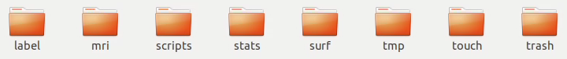Output: new directory (named SubjectID) in Output directory containing 8 folders
  + Scripts
    - *01a-reconstruction030T1_1pre*
    - *01a-reconstruction030T1_2post*

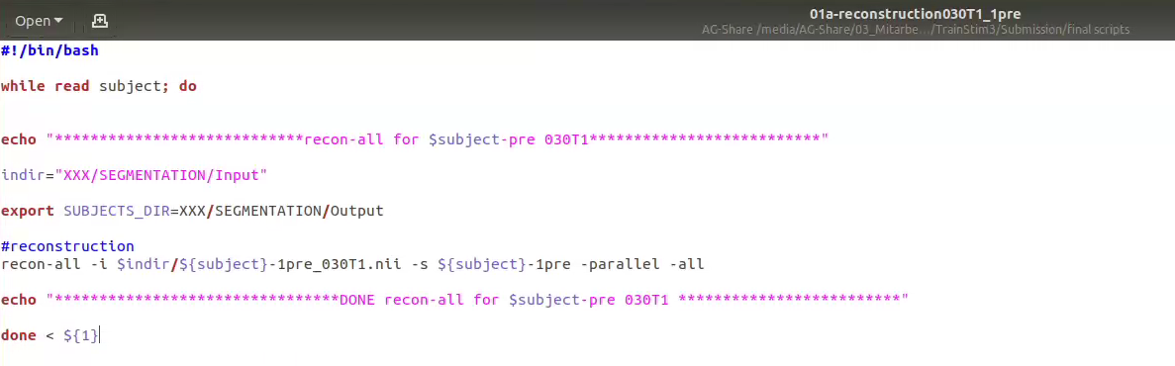

* Quality check
  + Check logfile: open /scripts/recon-all.log
  + "finished without error" should be written at the end of the file
  + Visual check if Segmentation worked: Overlay aparc+aseg image on T1 image for each subject
  + Run script: *02b-check_segmentation_freeview* (adapt paths)
  + opens T1 and aparc+aseg overlays one by one in freeview
  + check via Freesurfer Quality Control:
  + QA tools: $QA_TOOLS/recon_checker -s-file QA_check
    - <https://surfer.nmr.mgh.harvard.edu/fswiki/QATools>
  + Output: Table XXX with anatomical SNR
  + Scripts:
    - *02a-check_QATools*
    - *02b-check_segmentation_freeview*

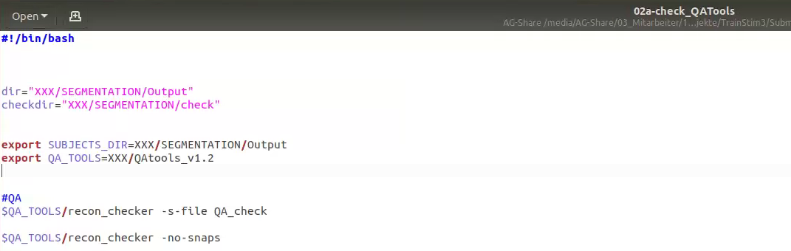

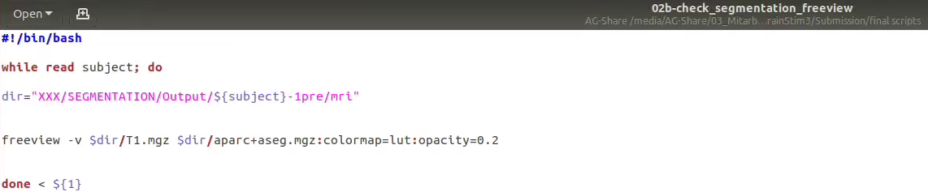

3. Start Longitudinal Pipeline (recon-all)

* prepare base template by running: *03-long_template_generation*
* Run Recon all for template
  + Adapt file names in recon-all long command Run script: 012a-reconstruction to do preprocessing and segmentation steps for T1.nii
    - Duration: 6-10 hours per subject (depending on use of -parallel flag)
    - Input: T1.nii files
    - **Output: new directory (named SubjectID) in Output directory containing 8 folders
  + Scripts
    - *03-long_template_generation*
    - *04a-recon_all_long_1pre*
    - *04a-recon_all_long_2post*

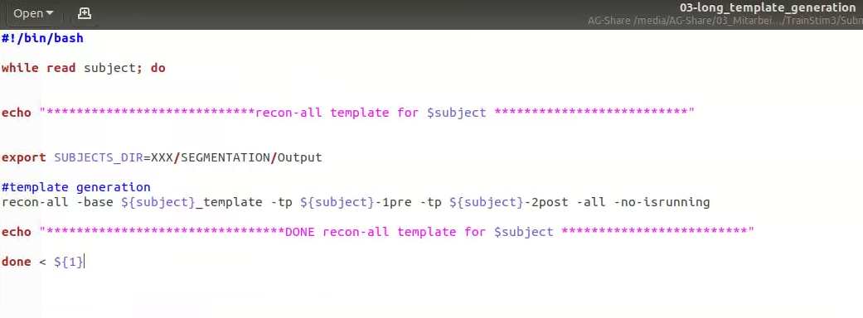

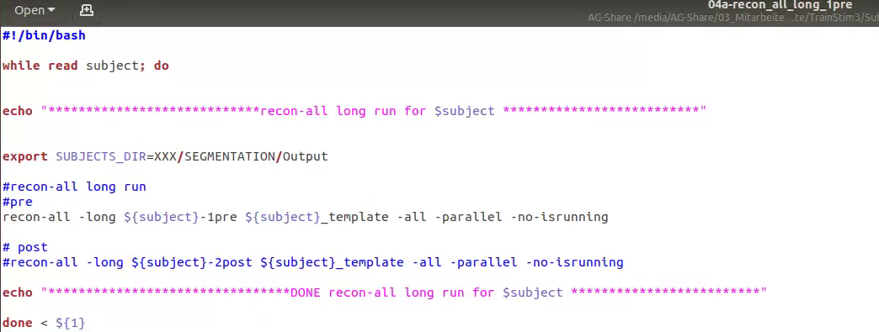

* Repeat Quality check with new data (see former section)
* Extract volumes / thickness / area size
  + Adapt and run script 13-stats2txt:
  + Output: txt files with volume and thickness of segmented regions
  + Scripts:
    - *05-stats2txt_1pre*
    - 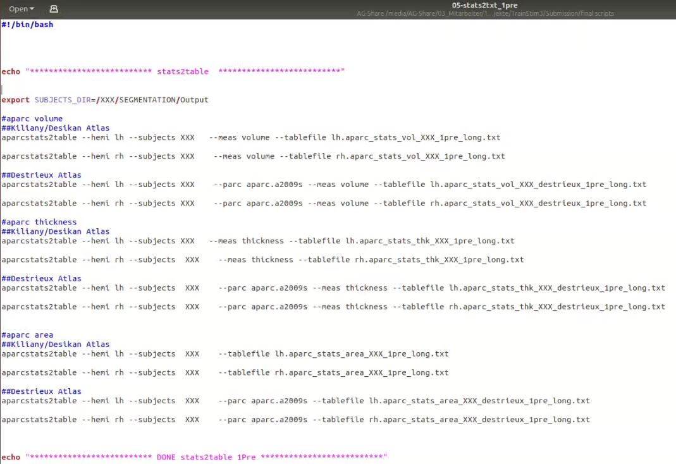*05-stats2txt_2post*
  + volumes are raw: for our analysis we adjusted for total intracranial volume (ICV) using the residual-method
* Create mask files of rmfg and cmfg, which will be combined with the tract area (ROI)
  + Adapt and run script 06-extract_ROI:
    - adapt paths / chose structures
    - (chosen structures in script: left caudal middle frontal gyrus, left rostral middle frontal gyrus)
    - Check intensity values of chosen structure in aparc+aseg.mgz file (threshold at +/- 0.5 of intensity value)
  + Output: .nii mask files of chosen structures (check fit by overlaying over aparc+aseg.mgz file in freeview)
  + Scripts:
    - 06-extract_ROI_1pre
    - 06-extract_ROI_2post

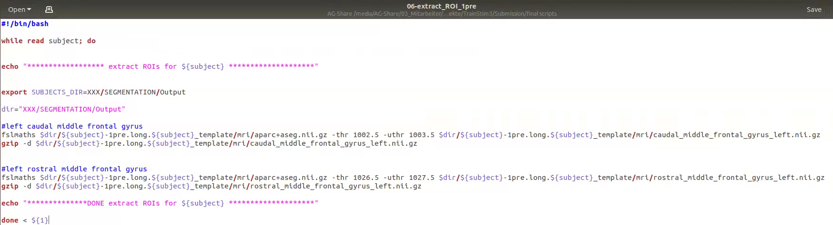

1. Start longitudinal TRACULA pipeline

* using the within-subject template from former analyses (Reconstruction)
* Prepare Scripts/ Directory Structure
  + go to *owndirectory/TRACULA*
  + Create folder for each subject in Input folder
* Copy DTI dicoms to input folder
  + Adapt script: 00b_cp_dicoms
  + Adapt paths / filenames in cp command
  + Scripts:
    - *07_dicom_rename_1pre*
    - *07_dicom_rename_2post*

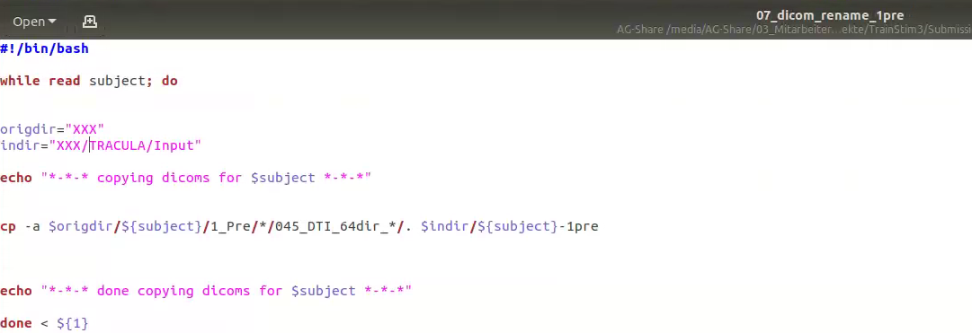

* adapt configuration file: dmrirc.long_XXX
  + section: set subjlist, set baselist, set dcmroot
    - further explanation within tutorial: <https://surfer.nmr.mgh.harvard.edu/fswiki/dmrirc>
* create a subject list and copy into configuration file
* create a base list and copy into configuration file
* dcmroot: run and copy output in configuration file
  + script:
    - *08_create_dcmlist*

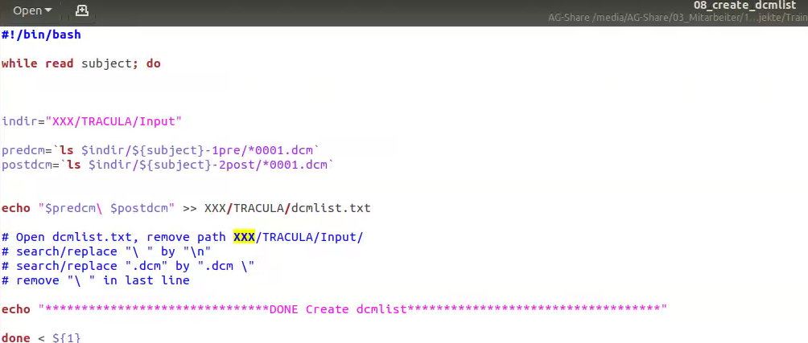

* run TRACULA
  + Adapt paths in scripts 01-02
  + **Run script: 09_prep_long**
    - Input: .dcm files from /Input directory (one file has to be named as the subject ID, the command will assume that all the rest are located in the same directory)
    - Output: Output will be under SEGMENTATION / Output
    - **Duration**: 7-8 hours per subject per time point

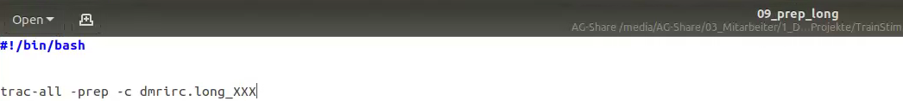

* + **Run script: 10_bedp_long**
    - to perform stick-and-ball model fitting on pre and post images
    - **Duration**: 7-8 hours per subject per time point

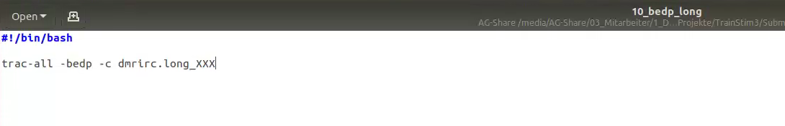

* Quality Check
  + Check after each step if /SEGMNTATION/Output/{subject}/scripts/trac-all.log says “finished without error”
  + Visually check FA to MNI registration and Reconstruction of all paths per subject.
  + Adapt paths and **run script: 11_openfiles_and_check** (comment / uncomment chosen checking step)
  + scripts:
    - 06_openfiles_and_check
  + Check for **motion measures** in /dmri/dwi_motion.txt
  + file contains four values:
    - average volume-by-volume translation
    - average volume-by-volume rotation
    - percent of slices with excessive intensity drop-out
    - average drop-out score for slices with excessive intensity drop-out
  + copy all files into one folder. Then import to Excel.

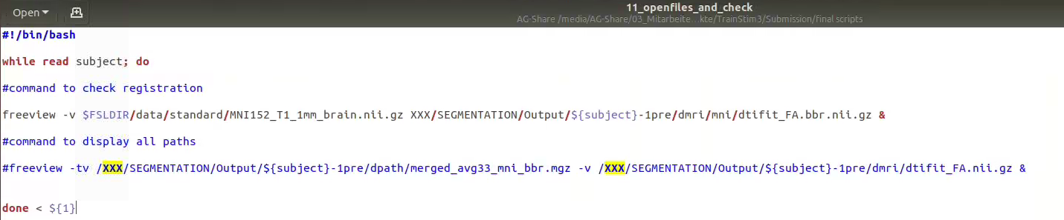

To get the MD of our ROI, lMidFG has to be extracted (see analysis: PROBTTRACKX2)

1. register cmfg and rmfg to DTI space, to combine it with lMidFG (ROI)

* Register T1.nii to FA space
  + Required: T1.mgz converted to .nii and extracted ROI masks
  + Adapt and run script 07b-subcortical_MD: adapt paths / adapt ROIs
  + Output: ROIs.nii in dti space
  + Scripts:
    - *12-ROI_MD_1pre*
    - *12-ROI_MD_2post*

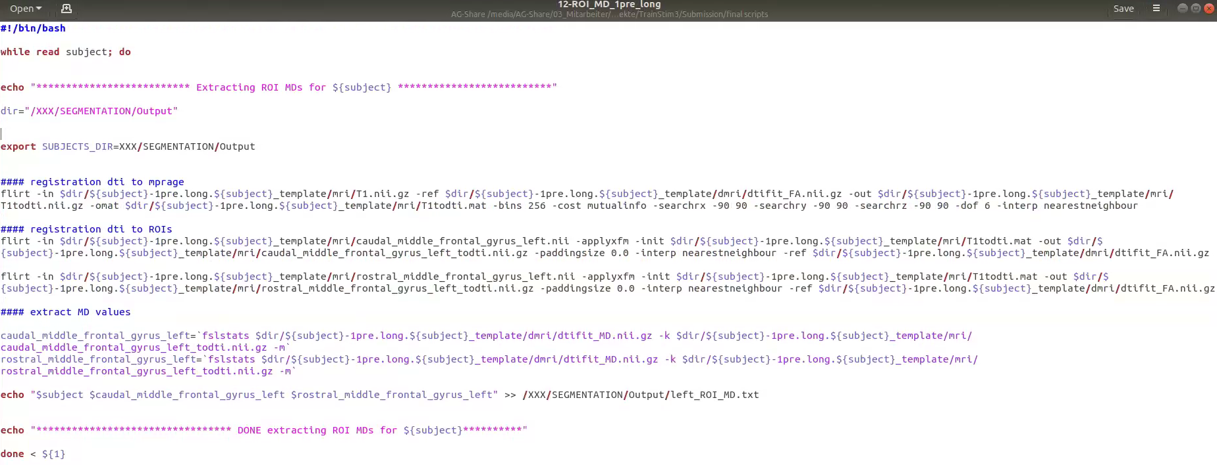

* + Check registration with slicesdir
  + Scripts:
    - *13-check_reg_T1todti*
    - (follow instructions in script for slicesdir)

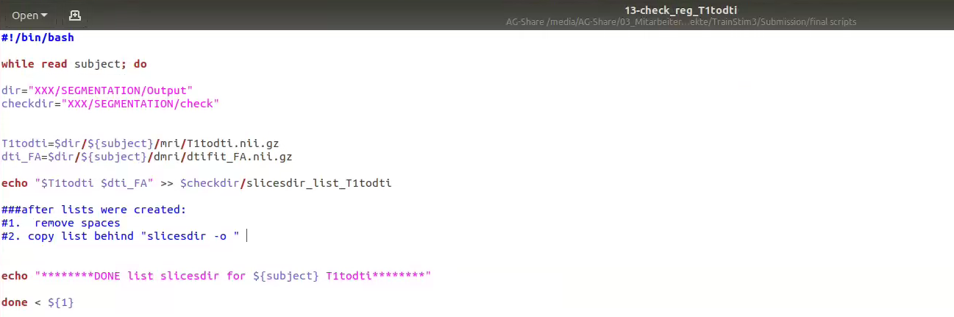

* Combine left middle frontal gyrus, left caudal middle frontal gyrus and lMidFG (ROI)
* extract MD of ROI
  + scripts
    - *14-invwarp_ROIs_1pre*
    - *14-invwarp_ROIs_2post*

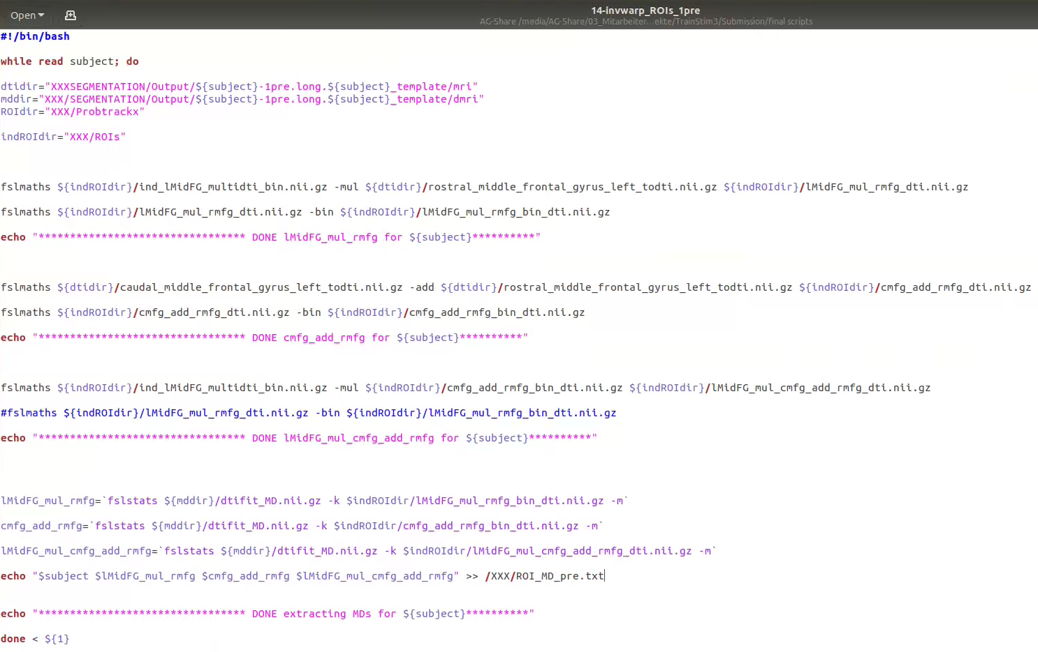

* + Output: txt file with MD for ROIs per subject